**WOOD ARTS**

***Submitted by***

Megha Hegde

2117082

MCA

Aloysius Institute of Management & Information Technology, Beeri, Mangaluru

***Under the guidance of***

**Mrs. Manimozhi R**

**Associate Professor, MCA Department**

Submitted to



**ST. ALOYSIUS INSTITUTE OF MANAGEMENT AND INFORMATION TECHNOLOGY (AIMIT)**

**ST. ALOYSIUS COLLEGE (AUTONOMOUS)**

**MANGALURU, KARNATAKA**

**2022**



**ST. ALOYSIUS INSTITUTE OF MANAGEMNT AND INFORMATION TECHNOLOGY (AIMIT)**

**ST. ALOYSIUS COLLEGE (AUTONOMOUS)**

**MANGALURU, KARNATAKA**

This is to certify that the project titled

# WOOD ARTS

# Submitted by

Megha Hegde

2117082

MCA

Aloysius Institute of Management & Information Technology, Beeri, Mangaluru

**During the year** 2022

|  | ***Examiners:*** |
| --- | --- |
| Dr Hemalatha N  Dean, School of IT  PG Dept. of Information Technology,  AIMIT, St. Aloysius College,  Mangaluru-575 022. | 1. |
| Mrs. Manimozhi R.  Associate Professor,  Department of MCA,  AIMIT, St. Aloysius College,  Mangaluru-575 022. | 2. |

**Table of Contents**

| **CHAPTER1: Refining the Business Model, Product and Services** | | |
| --- | --- | --- |
| 1.1 | Pivoting |  |
| 1.2 | Two Business Models |  |
| 1.3 | Analyse Business model of competitors |  |
| 1.4 | New Customer segment |  |
| 1.5 | Product Manager – Role and responsibilities |  |
|  |  |  |
| **CHAPTER2:Business Planning** | | |
| 2.1 | Business Plan |  |
| 2.2 | Make a Sales Plan, |  |
| 2.3 | Make a People Plan for your venture |  |
| 2.4 | Discuss Financial Plan and Revisit your Business Model |  |
|  |  |  |
| **CHAPTER3:Exploring ways to increase Revenue** | | |
| 3.1 | Understanding Primary Revenue Source |  |
| 3.2 | Exploring Customer Life Cycle for Growing Customers |  |
| 3.3 | Exploring Secondary Sources of Revenue |  |
|  |  |  |
| **CHAPTER4:Funding the Growth / Scalability** | | |
| 4.1 | Funding Options for an Entrepreneur |  |
| 4.2 | Create your Funding Plan |  |
| 4.3 | Preparing a Business Pitch Deck |  |
|  |  |  |
| **CHAPTER5:Building the A Team** | | |
| 5.1 | Building a A Team |  |
| 5.2 | Setting your Team up for Success |  |
| 5.3 | Defining the role of a new hire |  |
|  |  |  |
| **CHAPTER6:Creating Branding and Channel Strategy** | | |
| 6.1 | All about Branding |  |
| 6.2 | Define your values; All about Positioning statements |  |
| 6.3 | Create your Brand Name, Social Media Handler, and Logo; Identify your Right Channel. |  |
|  |  |  |
| **CHAPTER7:Leveraging Technologies and Available Platforms** | | |
| 7.1 | Leaping ahead with Technology |  |
| 7.2 | Digital Marketing for your Startup |  |
| 7.3 | Plan a Social Media Campaign; Digital Collaboration |  |
| 7.4 | Store your Documents online, other Platforms |  |
| **CHAPTER8:Measuring your Progress** | | |
| 8.1 | Metrics for Customer Acquisition – CAC+CLV + ARPU |  |
| 8.2 | Metrics for Customer Retention and Satisfaction |  |
| 8.3 | Key Financial Metrics |  |
| 8.4 | Find new Revenue Streams based on the financial metrics |  |
| **CHAPTER9:Legal Matters** | | |
| 9.1 | Identify Professional, Legal and Compliance requirement for your venture |  |
| 9.2 | Conduct a Trademark Search for your Company and Trade Name. |  |
| **CHAPTER10:Mentorship and Seeking Suppor**t | | |
| 10.1 | How Mentors help to create start-ups |  |
| 10.2 | Identify mentors and Advisors |  |
| 10.3 | Scout for Board of Directors |  |
|  |  |  |
| 11.1 | Conclusion |  |
| 11.2 | References |  |

**Refining Business Model, Product and Service**

**Chapter 1 Refining Business Model, Product and Service**

* 1. Pivoting:

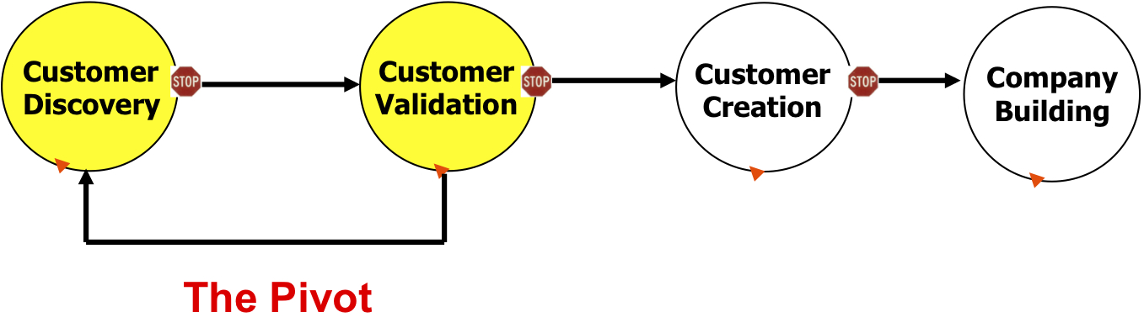

* 1. Two business Models:

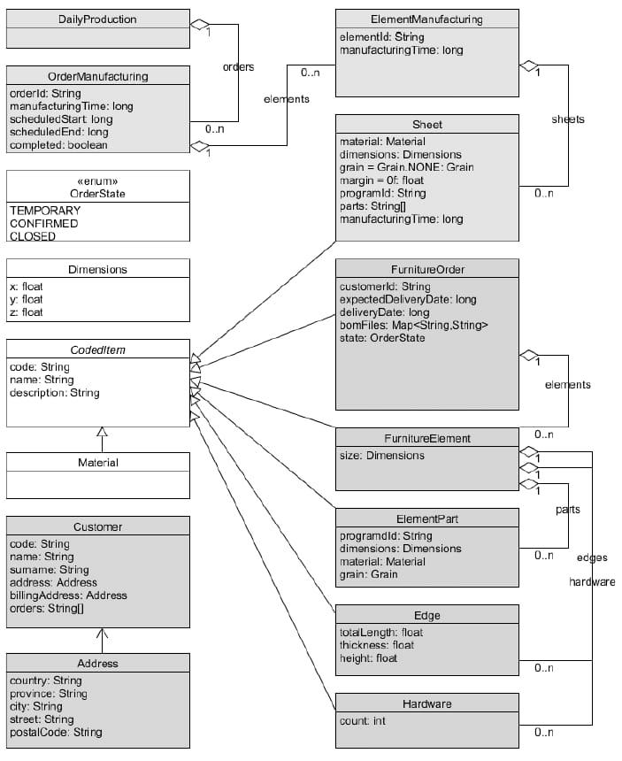

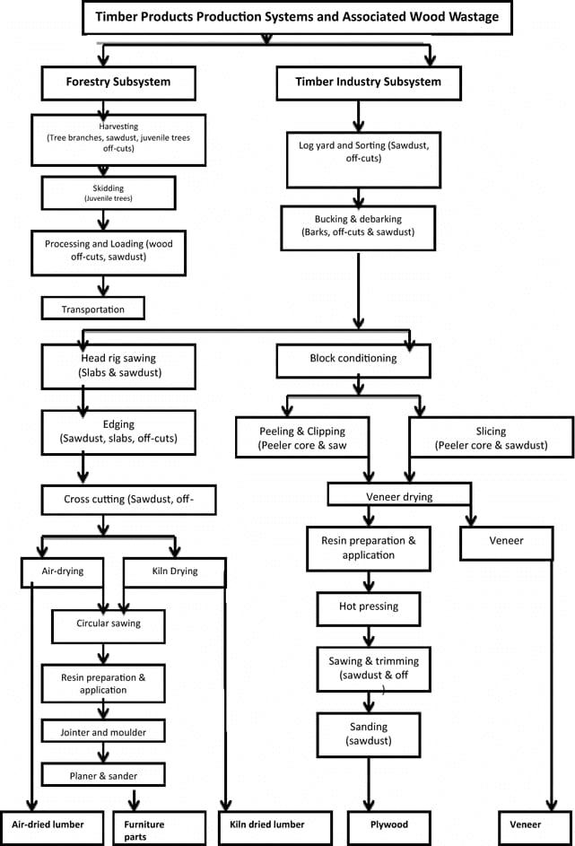

* 1. Analyze business Models of competitors:

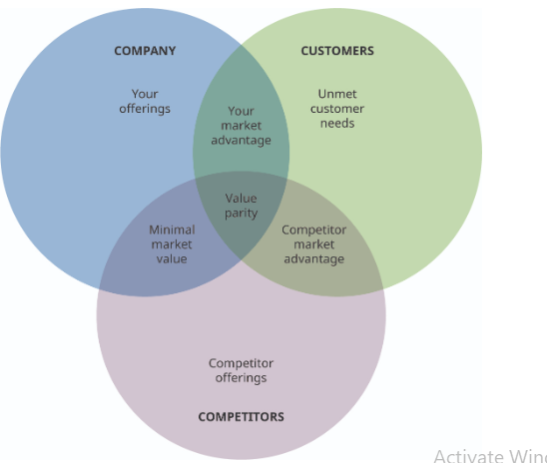

1.4 New customer segment

Market segmentation can help you to define and better understand your target audiences and ideal customers.

Types of Market Segmentation

1. Demographic Segmentation

Demographic segmentation is one of the most common forms. It refers to splitting up audiences based on observable, people-based differences. These qualities include things like age, sex, marital status, family size, occupation, education level, income, race, nationality and religion.

2.Behavioral Segmentation

You can also segment your market based on consumers’ behaviors, especially regarding your product. Dividing your audience based on behaviors they display allows you to create messaging that caters to those behaviors. Many of the actions you might look at relate to how someone interacts with your product, website, app or brand.

Online shopping habits: You might consider a users’ online shopping habits across all sites, as this may correlate with the likelihood they will make an online purchase on your website.

Actions taken on a website: You can track actions users take on your online properties to better understand how they interact with them. You might look at how long someone stays on your site, whether they read articles all the way to the end, the types of content they click on and more.

Benefits sought: This refers to the need a customer is trying to meet by purchasing a product.

Usage rate: You can categorize users based on usage rate. Your messaging will be different depending on whether someone is a heavy user, medium user, light user or non-user of your product.

Loyalty: After using a product for some time, customers often develop brand loyalty. You can categorize customers based on how loyal they are to your brand and tailor your messaging accordingly.

Behavioral data is useful because it relates directly to how someone interacts with your brand or products. Because of this, it can help you market more effectively to them.

You can collect this data through various sources including cookies placed on your website, the purchase data in your customer relationship management (CRM) software and third-party datasets.

3.Geographic Segmentation

4.Psychographic Segmentation

Psychographic segmentation is similar to demographic segmentation, but it deals with characteristics that are more mental and emotional. These attributes may not be as easy to observe as demographics, but they can give you valuable insight into your audience’s motives, preferences and needs. Understanding these aspects of your audience can help you to create content that appeals to them more effectively. Some examples of psychographic characteristics include personality traits, interests, beliefs, values, attitudes and lifestyles.

1.5Product Manager-Role and responsibilities:

Specific responsibilities vary depending on the size of the organization. In larger organizations, for instance, product managers are embedded within teams of specialists. Researchers, analysts, and marketers help gather input, while developers and designers manage the day-to-day execution, draw up designs, test prototypes, and find bugs. These product managers have more help, but they also spend more time aligning these stake holders behind a specific vision.

On the flip side, product managers at smaller organizations spend less time getting everyone to agree, but more time doing the hands-on work that comes with defining a vision and seeing it through, good product manager will spend his or her time on a handful of tasks. Understanding and representing user needs, Monitoring the market and developing competitive analyses, Defining a vision for a product, Aligning stakeholders around the vision for the product, Prioritizing product features and capabilities, Creating a shared brain across larger teams to empower independent decision-making.

**Business Planning**

**Chapter2 Business Planning**

2.1 Business Plan:

We will be preparing our own raw material which is required. i.e. we will buy it directly from certified forestry

We will provide all the interiors made up of wood to a newly built home accordingly to the user.

We will manufacture all kind of wood products including furniture, showpieces, wooden interior etc with all kinds of wood where as other companies provide a wood product made of any particular kind of wood.

2.2 Make a sales point:

First we will make our business start from scratch that is from remote areas ,we will distribute pamphlets and advertise our products through different medias like TV ,news paper ,social media etc…

* 1. make a people plan for your venture:

To achieve business success we need to be organize our plan. Keeping Detailed Records of our business files, and will Analyze our Competition, Competition breeds the best results.

Understanding the Risks and Rewards, we should be creative enough to make our business success .we should be Stay Focused to our business ,and we should be Prepared to Make Sacrifices to achieve our plan to be succeeded and finally ,we will provide Provide Great Service to the customers .

2.4 Discuss Financial Plan and Revisit your Business Model

A financial plan helps determine if an idea is sustainable, and then keeps you on track to financial health as your business matures. It’s an integral part to an overall business plan and is made up of three financial statements—cash flow statement, income statement and balance sheet. In your plan, each of these will include a brief explanation or analysis.

Key Takeaways

A financial plan helps you know where your business stands and lets you make better informed decisions about resource allocation.

A financial plan has three major components: a cash flow projection, income statement and balance sheet.

Our financial plan answers essential questions to set and track progress toward goals.

Using financial management software gives you the tools to make strategic decisions efficiently.

**Exploring Ways to Increase Revenue**

**Chapter3 Exploring Ways to Increase Revenue**

3.1 understanding primary revenue source:

A customer lifecycle refers to a journey of discovering a product or brand to becoming a loyal customer and eventually stop buying from the brand altogether.

3.2 exploring customer lifecycle for growing customer:

# How to Get People to Buy Your Products:

# 1.Drive Traffic to Your Website

# Everything starts with getting traffic to your website, putting your product or service in front of a target audience. Traffic is the first step into the [process of customer acquisition](https://popupsmart.com/blog/customer-acquisition-process)

### Leave Perfect First Impressions & Encourage to Discover More Content

### The second step on how to get people to buy your product is all about impressions and building a strong emotional connection with your potential customers.

### Build a Trust Relationship Between Your Brand and Customers

To gain your customers’ trust, you should be willing to solve their problems and offer them help. Over time, you will earn their trust and build customer loyalty.To ensure that, you should have excellent and warm customer service.

3.3 exploring secondary source of revenue:

Investors can give you funding to start your business in the form of venture capital investments. Venture capital is normally offered in exchange for an ownership share and active role in the company.

Venture capital differs from traditional financing in a number of important ways. Venture capital typically:

* Focuses high-growth companies
* Invests capital in return for equity, rather than debt (it’s not a loan)
* Takes higher risks in exchange for potential higher returns
* Has a longer investment horizon than traditional financing

**Funding the Growth or Scalability**

**Chapter4 Funding the Growth or Scalability**

4.1 funding option for an Enterprenuer

1. Find an investor   
   Look for individual investors — sometimes called “angel investors” — or venture capital firms. Be sure to do enough background research to know if the investor is reputable and has experience working with startup companies.

1.Share your business plan

 The investor will review your business plan to make sure it meets their investing criteria. Most investment funds concentrate on an industry, geographic area, or stage of business development.

1. Go through due diligence review   
   The investors will look at your company’s management team, market, products and services, corporate governance documents, and financial statements.
2. Work out the terms   
   If they want to invest, the next step is to agree on a term sheet that describes the terms and conditions for the fund to make an investment.
3. Investment  
   Once you agree on a term sheet, you can get the investment! Once a venture fund has invested, it becomes actively involved in the company. Venture funds normally come in “rounds.” As the company meets milestones, further rounds of financing are made available, with adjustments in price as the company executes its plan.

4.2 Create your funding plan:

Every business has different needs, and no financial solution is one-size-fits-all. Your personal financial situation and vision for your business will shape the financial future of your business.

Once you know how much [startup funding](https://www.sba.gov/business-guide/plan/calculate-startup-costs-small-business) you’ll need, it’s time to figure out how you’ll get it.



#### Self-funding Investors Loans

## Fund your business yourself with self-funding

Otherwise known as bootstrapping, self-funding lets you leverage your own financial resources to support your business. Self-funding can come in the form of turning to family and friends for capital, using your savings accounts, or even tapping into your 401(k).

With self-funding, you retain complete control over the business, but you also take on all the risk yourself. Be careful not to spend more than you can afford, and be especially careful if you choose to tap into retirement accounts early. You might face expensive fees or penalties, or damage your ability to retire on time — so you should check with your plan’s administrator and a personal financial advisor first.

4.3 Preparing business pitch deck:

A business plan will help you raise funding, if needed, and plan out the growth of your woodworking business to improve your chances of success. Your woodworking business plan is a living document that should be updated annually as your company grows and changes.

There are two ways of creating a woodworking business plan, formal and informal plan. Formal plans are usually created for seeking funding and sponsorship from lending institutions. Informal ones are more for you own assistance

**Building the A Team**

**Chapter5 Building the A team**

5.1 building A team

A woodworking business can be successfully run as a one-person operation, and some business owners never hire an employee. Those that do hire workers often only bring people on once the business’ sales can support an employee’s salary.

5.2 setting your team up for success:

Good teamwork is one of the key components that leads a business to success. The ability to hire the right people and build a successful and powerful team determines the long-term success of any organisation. Good organisations need high-performing team that can communicate clearly to achieve business objectives.

A successful team is essential to take an idea from inception to completion. There is a limitation on how much a single person can get done and it requires a strong team to execute a business plan and achieve success.

5.3 defining the role of new hier

One of the greatest resources an entrepreneur can have is quality mentorship. As you start planning your business, connect with a more people.

Having a support network in place to turn to during tough times is a major factor of success for new business owners.

**Creating Banding and Channel Strategy**

**Chapter 6 Creating Banding and Channel Strategy**

6.1 all about the branding

Your brand is what your company stands for, as well as how your business is perceived by the public. A strong brand will help your business stand out from competitors.

The internet makes it easy to market a woodworking business for little cost. There are several ways to promote a wood shop online: social media platforms give businesses a method of targeting particular demographics

6.2 define your values ,all about positioning statements

The purpose of a positioning statement is to convey a brand's [value proposition](https://blog.hubspot.com/marketing/write-value-proposition) to its ideal customers. It also frames the brand's identity, purpose, and distinguishing features within the context of the buyer’s experience.

6.3 create your brand name, social media handler ,and logo, identify your right channel

We’ll use our website to promote our services and goods by posting images of our finest and most distinctive stuff. We’ll also use social media, posters, and brochures to market the wood-based interior design concepts we came up with. To stimulate sales during the early stages of the launch, the company will provide a discount on all services.

**Leveraging technologies and available platforms**

**Chapter7 Leveraging technologies and available platforms**

7.1: Leaping ahead with technology:

A woodworking business can set itself apart from other wood shops by offering high-quality products at reasonable prices, and by educating customers about the crafting process. In-person conversations, pamphlets and even tags can be used to share with customers what work went into making a piece and why that piece is different from ones produced by competitors.

7.2 Digital marketing for your startup:

[Woodworking](https://en.wikipedia.org/wiki/Woodworking)is in great demand all year, especially in well-established towns or renowned tourist sites. Above all, the need for this service is growing by the day, according to the same source, which states that the industry is growing .

Traditionally, a marketing plan includes the four P’s: Product, Price, Place, and Promotion. For a woodworking business plan, your marketing strategy should include the following:

**Product**: In the product section, you should reiterate the type of woodworking company that you documented in your company overview. Then, detail the specific products or services you will be offering. For example, will you provide plywood manufacturing, wooden interior products, wooden furniture, or wooden jewelry?

**Price**: Document the prices you will offer and how they compare to your competitors. Essentially in the product and price sub-sections of your plan, you are presenting the products you offer and their prices.

**Place**: Place refers to the site of your woodworking company. Document where your company is situated and mention how the site will impact your success. For example, is your woodworking business located in a busy retail district, a business district or purely online? Discuss how your site might be the ideal location for your customers.

7.3 Plan social media campaign, Digital collaboration

Event and Resort Managers: A significant portion of our target market will be restaurant or bar owners searching for unique and new ways to use wood into their designs. We’ll provide them discounts and unique offers if they employ our services to decorate their interior and outside, as well as to make wood designated sets for special events.

Institutions and Enterprises: To maintain a pleasant environment, educational institutions, workplaces, and businesses choose woodwork for interior design. We’ll send them our pamphlets and offer them discounts so they may try out our services and learn more about our skills and ideas for embellishing their workplaces, terraces, grass borders, stairwells, and entrances, among other places.

6.Strore your documents online ,other platforms

Woodcraft is going to show us some amazing wood constructions. Our wooden décor pieces and little and large sculptures, which people may use in their homes or give as gifts, will definitely appeal to local residents and visitors. This group is likely to buy our wooden chests, cradles, and other well carved wooden products, as well as engage us to adorn their lawns and galleries.

**Measuring your Progress**

**Chapter8 Measuring your Progress**

* 1. Metrics for Customer acquisition:

We can produce content and pay site owners, Facebook, and Twitter to bring it in front of your audience. You will buy ads from Google, so they place your site on the front row of their search results. We will  incentivize influencers in your niche to promote your product.

We can always spend *more* money to acquire customers — you can bid on the crazy-expensive keywords on Google or run a partnership with your favorite NBA star.

But no matter what tactic and channels you choose and how much we spend in each of them, our business won’t make it unless we find a place where customers are paying more to use your product than we pay to reach and convince them.

8.2 Matrix for customer Retention and satisfaction:

* Starting a business requires analytical thinking, determined organization, and detailed record-keeping.
* It’s important to be aware of our competition and either appropriate or improve upon their successful tactics.
* You’ll almost certainly end up working harder for ourself than we would for someone else, so we have to prepare to make sacrifices in your personal life when establishing our business.
* Providing good service to our customers is crucial to gaining their loyalty and retaining their business.
* Make sure not only that the business is ready for launch, but we are as well.

8.3 Key financial Matrix:

First and foremost, we will sell our product that people need, use and pay for. this is probably all that you are thinking about, we will bulid a startup  building a that solves customers’ problems and is worthy of their financial commitment.

Following steps we will foloow for financial matrix-

1.Customer Lifetime Vlaue:

First we will start from scratch and bulid a business in such a way that all the remote area customers will have acess to our products as per their requirements.

We will provide our customers a membership that it will helpful for them for next purchases.In that subscription product ,we will calculate LTV by first determining the customer value by multiplying the average purchase value by the purchase frequency. Multiply the average customer value by the average period (in months or years) that the customer is retained.

For eg if the money we can make from a customer, we will have a much clearer idea of how much money we should invest in acquiring a new customer.

2. Customer Acquisition Cost

CAC or customer acquisition cost is the money that we spend on acquiring a customer. When we launch our startup with a new product and unknown brand, our CAC may be high, but as we understand our ideal customer, find our best performing marketing channel, and will gain referrals through ourearly adaptors, our CAC can start declining. CAC includes our expenditure on sales, marketing,and distribution activities.

3. Churn Rate

Churn rate will indicate the percentage of our paying customers that canceled their purchase. This is a metric that we should aim to keep as low as possible.

4. Customer Retention

Customer retention is the opposite of churn rate. It indicates the percentage of our paying customers that we retained, who renewed their subscription to our product. High retention means we are delivering the promised value to our customers and they are happy with our product.

5. Cash Flow

Cash flow measures our costs versus revenue as it captures money going in and out of our business. Positive or free cash flow indicates liquidity with more money flowing into the business than out of it.

6. Return On Investment

ROI or return on investment is a metric for calculating the gains or losses derived from an investment we made. To calculate our return on investment in a new venture, project or initiative, divide our profits or losses by our total investment and multiply the result by 100 to get the ROI in percent.

7. Burn Rate

Burn rate means the amount of capital that we are spending or “burning” to finance operation. The burn rate of our startup can depend on the business model, funding and growth strategy.

8. Revenue

Revenue is the money that we generate through sales and is a measure of startup performance. However, in many cases, revenue is not an accurate measure of our company’s financial health as it does not take into account business expenses.

9. Net Income

Our net income is the difference between our revenue and expenses. Paying close attention to our customer’s lifetime value, customer acquisition cost, churn rate, retention, cash flow, return on investment and burn rate will help you increase the difference between your revenue and expenses, thus run a profitable startup venture while understanding the key metrics that play a big role in boosting our company’s financial performance.

8.4: Find new revenue source:

* increasing our prices as our business starts growing
* finding new customers by advertising or pamphlets ,and online purchasing through our own website
* selling more to existing customers.
* offering sale promotions to boost the volume of sales.
* developing new product or service lines.
* selling in new markets.

**Legal Matters**

**Chapter9 Legal Matters**

9.1 Identify Proffesional ,Leagal compliance requirement for your venture:

If we don’t have the licence for our business there are lower chances of gaining funds.

Investors may lose faith and may eventually lead business to shut .

Therefore ,licening is one of the basic hygine an early stage startup go for so that we are getting the licence from the government for the wood materials that we are going to use for our business.

9.2 conduct a trademark search for your company and trade name:



Describe the Products or Services being sold with the mark.Identify Specific Terms for Your Product or Service using the online Acceptable Identification of Goods & Services Manual.  Determine International Class.

Determine Related Goods or Services, and their Classes Developing a Basic Search Strategy. Broaden our Search Strategy. Consider searching with alternative spellings and homonyms to your mark. Using words that have the same or similar meanings to our mark. Also try words that have similar sounds or appearances or even phonetic equivalents.

Conduct the Search. Search on TESS--the USPTO's web-based Trademark Electronic Search System-at your local Patent and Trademark Resource Center ( for eg:[www.woodarts.gov/ptrc](http://www.woodarts.gov/ptrc)) or at home if you have Internet access.

 Describe the Products or Services being sold with the mark.Identify Specific Terms for Your Product or Service using the online Acceptable Identification of Goods & Services Manual. Determine International Class.

Determine Related Goods or Services, and their ClassesDeveloping a Basic Search Strategy. Broaden our Search Strategy. Consider searching with alternative spellings and homonyms to your mark. Using words that have the same or similar meanings to our mark. Also try words that have similar sounds or appearances or even phonetic equivalents.

Conduct the Search. Search on TESS--the USPTO's web-based Trademark Electronic Search System-at your local Patent and Trademark Resource Center ( for eg:[www.woodarts.gov/ptrc](http://www.woodarts.gov/ptrc)) or at home if you have Internet access.

**Mentorship and Seeking Support**

**Chapter10 Mentorship and Seeking Support**

10.1 How mentors help to create start-ups:

The main purpose of a mentor is to help entrepreneurs with specific questions by sharing their knowledge and contacts harvested through their years of experience. Therefore, a mentor must not only fulfill their executive functions, but also understand the process and evolution of the project.

There are four steps that a mentor needs to take when helping a mentee with their startup:

Step 1: Hold a meeting with the mentee.

Step 2: Advise them.

Step 3: Share your contacts.

Step 4: Give feedback.

10.2 Identify mentors and advisors:

We will identifying mentors using online platforms (for eg:https://neilpatel.com/blog/find-mentor/)

10.3 scout for board for directors:

1. Be a registered member of Girl Scouts of the USA.
2. Financially support Girl Scouting at the leadership level.
3. Make a concerted effort to attend five board meeting, the annual council meeting, and board training.
4. Be a positive role model and advocate for Girl Scouts.
5. Serve on at least one council committee.
6. Have a clear understanding of the council’s long-range strategic plan.

CONCLUSION:

In this business study several factors that affect the export performance of furniture. These factors are raw material supply, government policy, exchange rate and economic indicators, which is an import price index. Other factors that have been covered briefly are technology, labor, and marketing. It is important to maintain a low cost of labor and raw material as Malaysian furniture competitiveness depends on these two factors.

An increase in the average wage of workers, which exceeds the rate of increase in labor productivity, will lead to an increase in unit labor cost .The increase in unit labor cost could subsequently affect the competitiveness .In this regard, trained and skilled workers should also be provided to the industry particularly in the area of production technology and finishing.

REFERENCES:

* <https://www.researchgate.net/figure/Gateway-data-model-Class-diagram_fig1_325876286>
* <https://www.lucidchart.com/blog/uml-diagram-templates>
* <https://owic.oregonstate.edu/sites/default/files/pubs/wp_planning_guide.pdf>
* <https://www.investopedia.com/terms/b/businessmodel.asp>
* [https://www.qualtrics.com/au/experience-management/brand/customer- segmentation/?rid=ip&prevsite=en&newsite=au&geo=IN&geomatch=au](https://www.qualtrics.com/au/experience-management/brand/customer-%20segmentation/?rid=ip&prevsite=en&newsite=au&geo=IN&geomatch=au)
* <https://www.aubrilam.com/from-the-raw-material-to-the-finished-product-discover-the-9-steps-of-the-whole-manufacturing-process-of-our-glued-laminated-wooden-columns.html/>